ACE OF CARTS:
Order To Cash

Creating a Sales Order:
Enter Sales Order functionality. (Standalone Sales Order)
Login to NetSuite using Administrator Role. Navigate: Transactions -> Sales -> Enter Sales Orders.
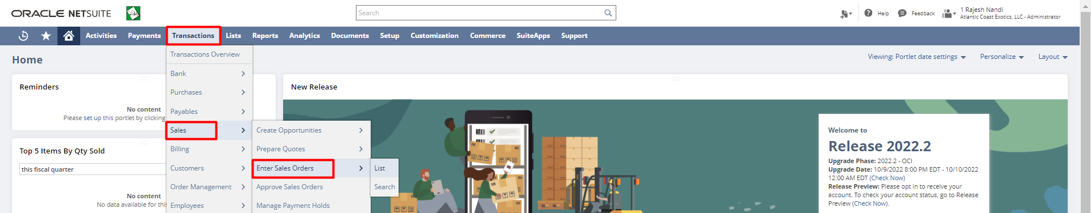

Select the Customer. Select an Item. Enter the Rate, Quantity and other required fields. Click the “Save” button.

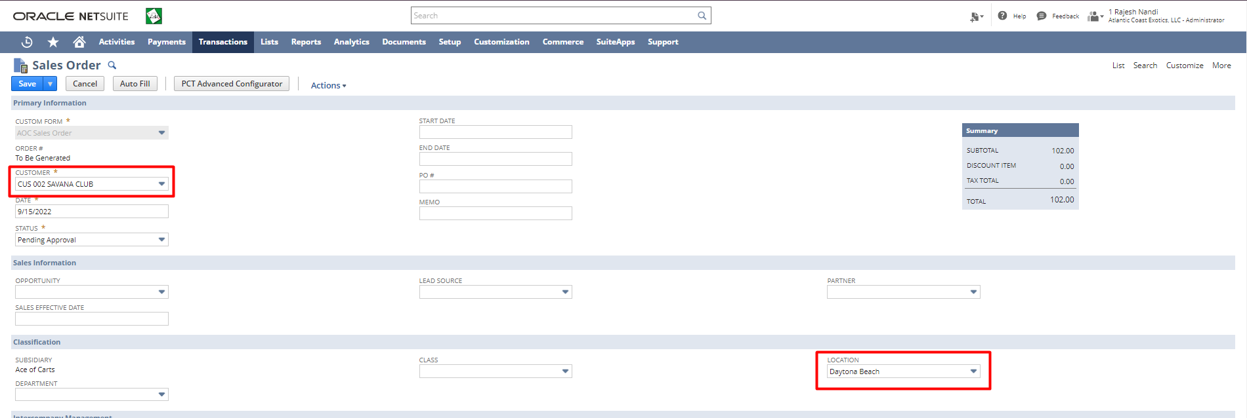
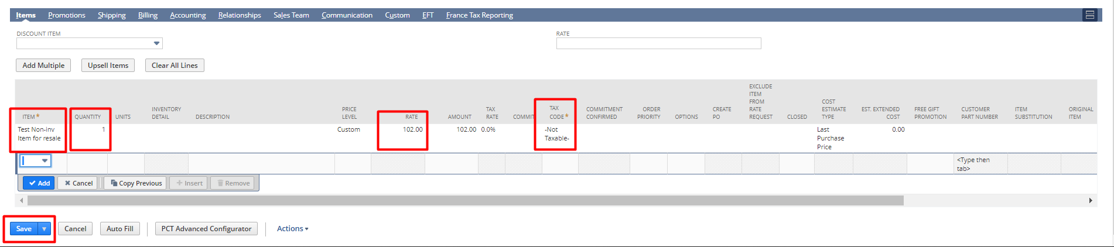
NOTE: This is a Standalone Sales Order.
Fulfilling a Sales Order:
If there is enough Inventory/enough quantity available in your warehouse to fulfill a Sales Order you can directly fulfill it. However, if you are short of inventory to fulfill a Sales Order /if not, you can create a Purchase Order to increase inventory for the Item.
To fulfill a Sales Order, follow these steps:
There are two ways to Fulfill Sales Order
- From Sales Order
- Bulk Fulfillment
From Sales Order
Login to NetSuite with Administrator Role. Navigate: Transactions -> Sales -> Enter Sales Order -> List.
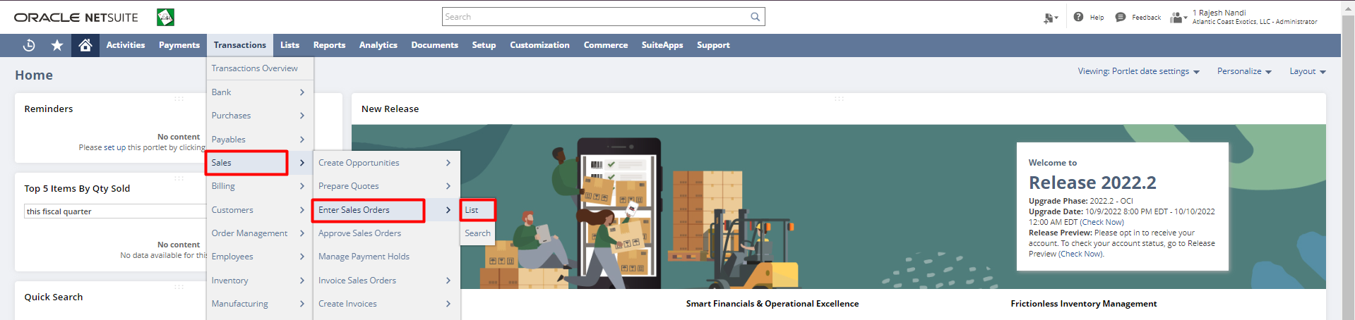

Click “View” on the Sales Order you want to Fulfill.
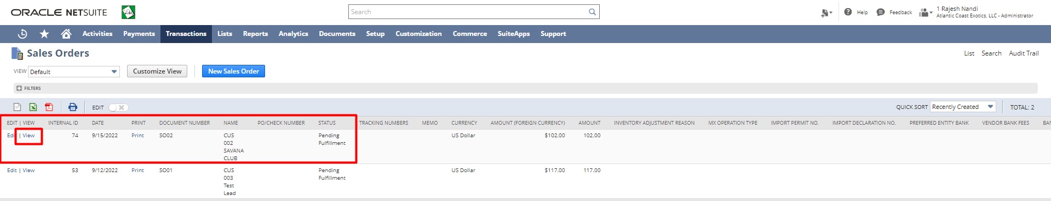
Click on the “Fulfill” button.
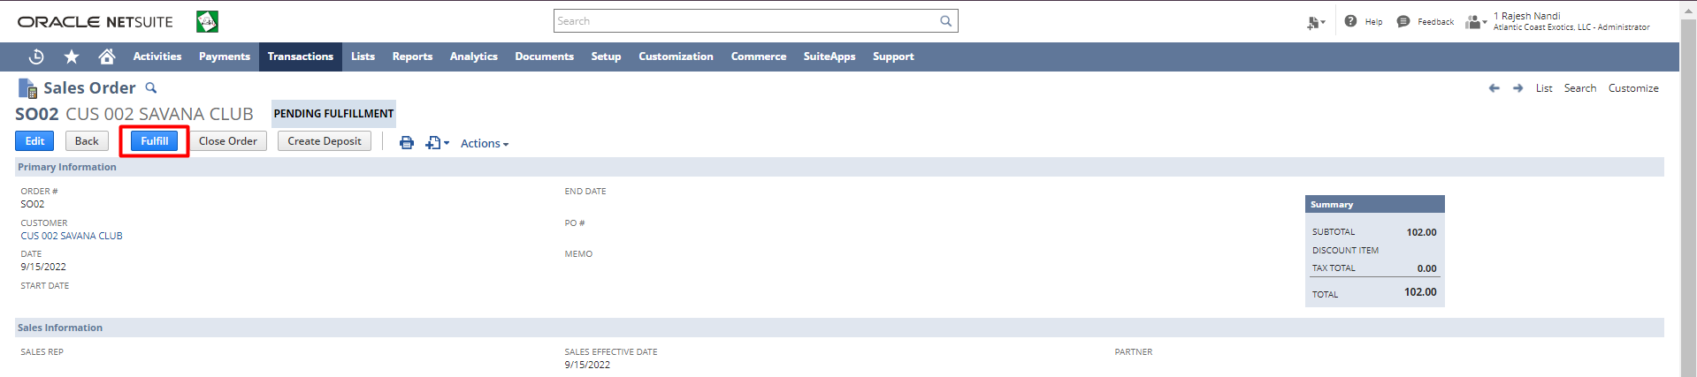
Select a Status for the Fulfillment. In the line level check the fulfill checkbox for the Items you want to Fulfill. Select a Location, Quantity for the fulfillment. Click on the “Save” button.
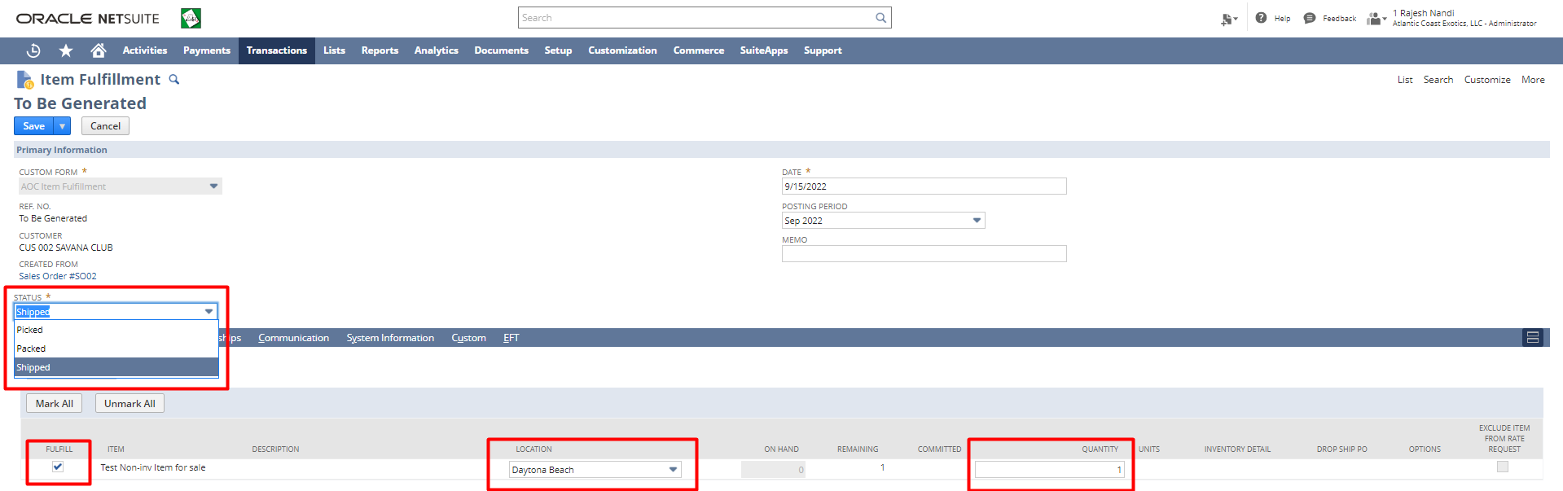

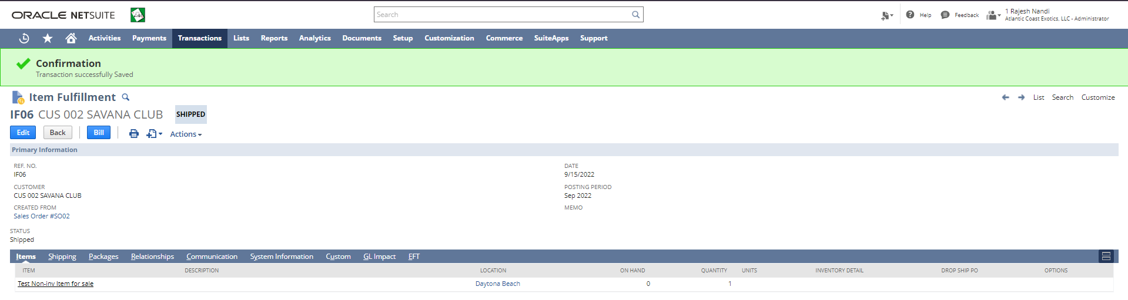
Bulk Fulfillment
- Login to NetSuite with Administrator Role. Navigate: Transactions -> Order Management -> Fulfill Order.
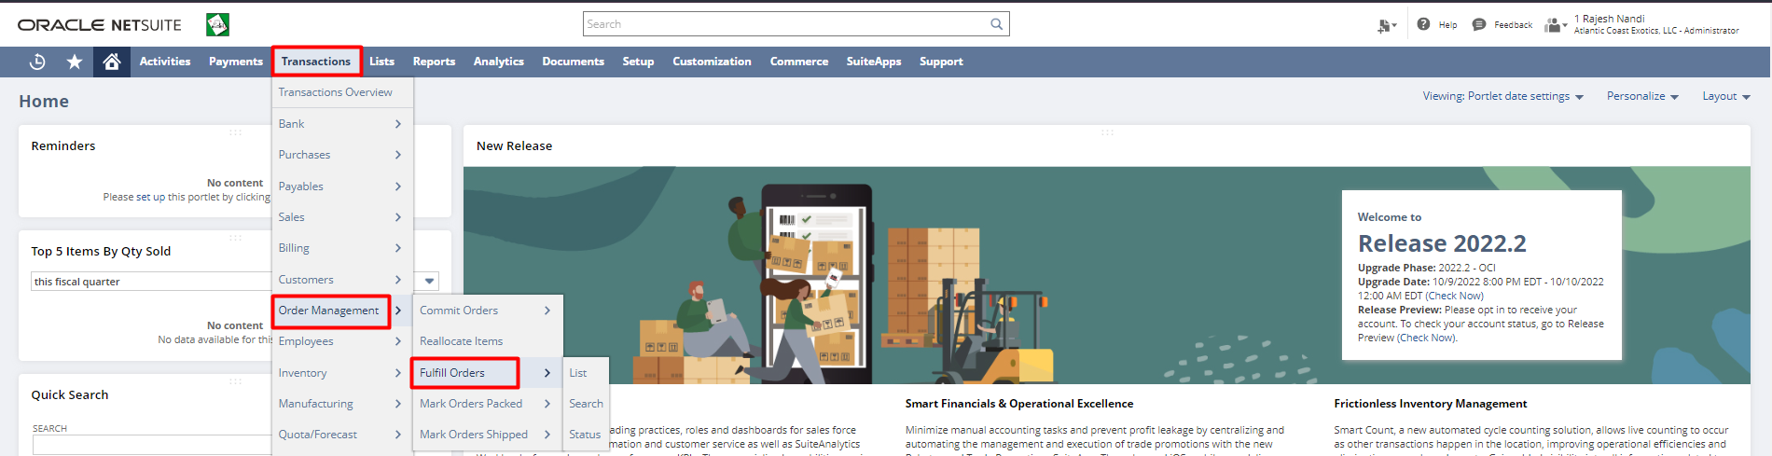

Creating Invoices:
- Stand Alone
- From Sales Order
Stand Alone Invoice
- From Administrator Role
1.Login to NetSuite with Administrator Role. Navigate: Transactions -> Sales -> Create Invoices.
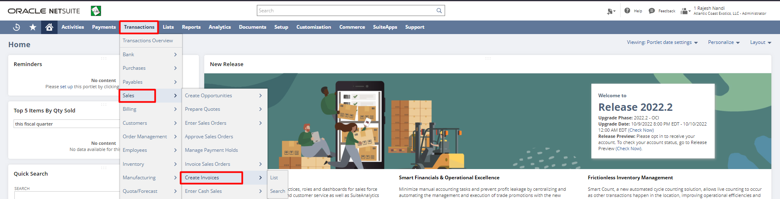
Select Customer, Location, Item and all the required details. Click on the “Save” button.

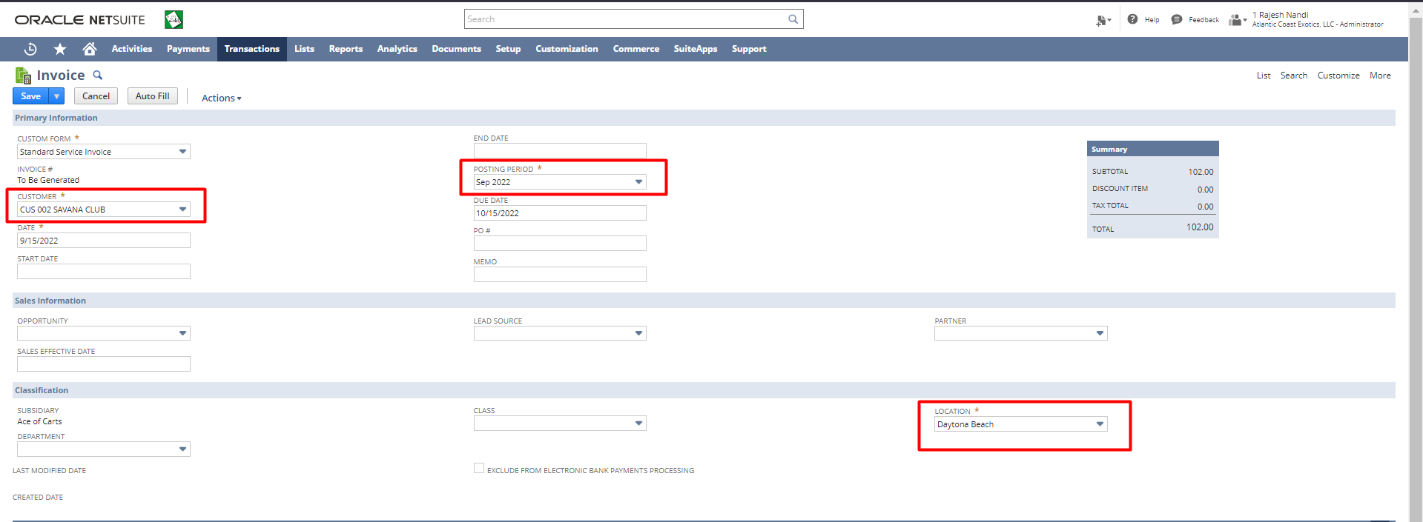
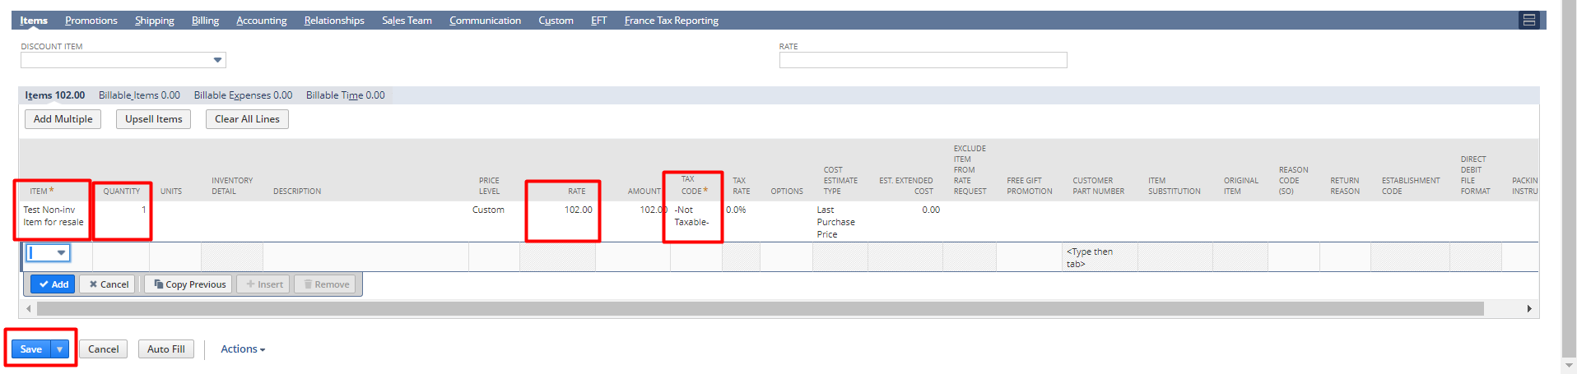
Invoice From Sales Order
Login to NetSuite with Administrator Role. Navigate: Transactions -> Sales -> Enter Sales Orders -> List.

Click “View” on the Sales Order you want to Invoice.

Click on the “Bill” button.
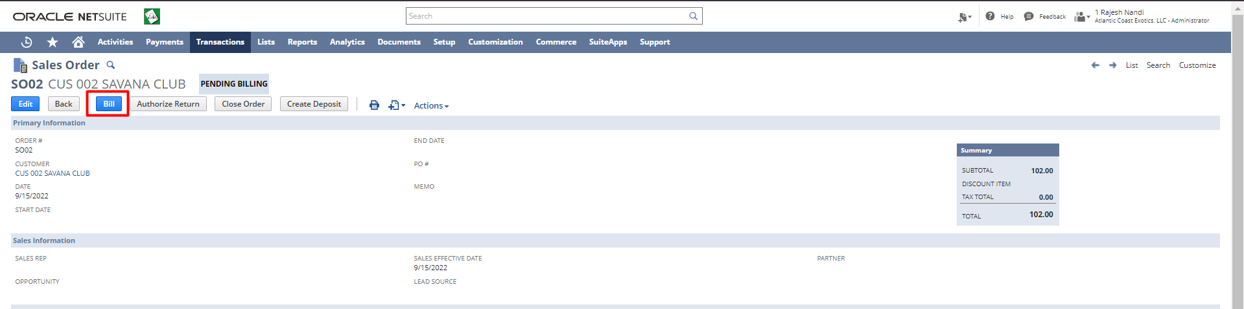
Enter additional details if any. Click the “Save” button.
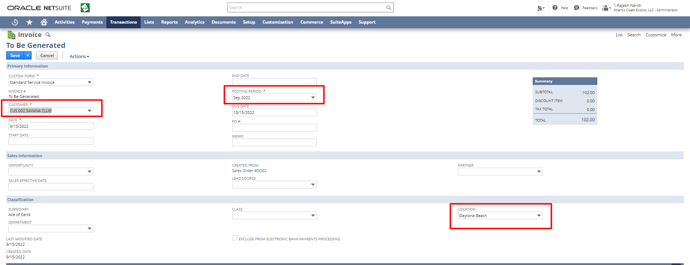
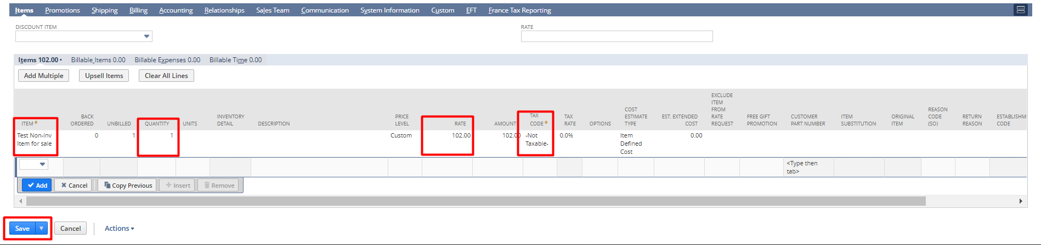

Creating Customer Payments
- Stand Alone
- From Invoice
Stand Alone Payment
1.Login to NetSuite with Administrator Role. Navigate: Transactions -> Customers -> Enter Customer Payments -> List.
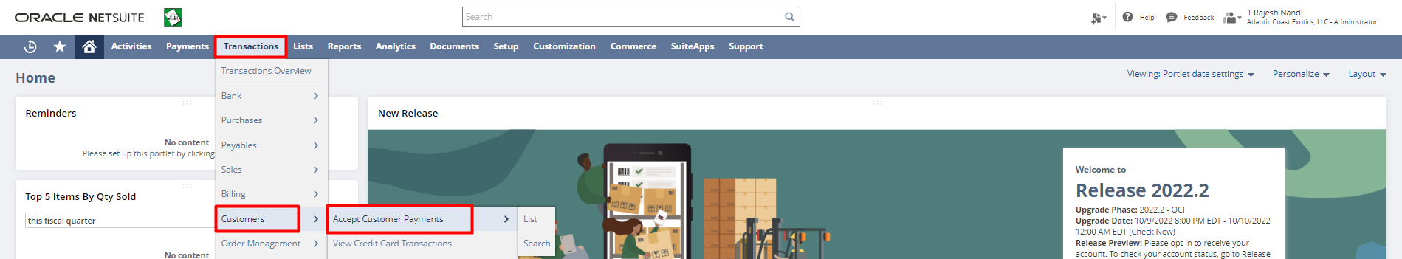

Select Customer and all the required details. Click on the “Save” button.
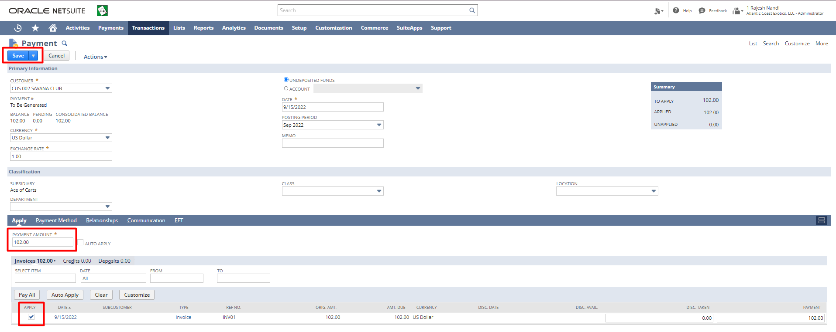
Accepting Payment From Invoice
- Login to NetSuite with Administrator Role. Navigate: Transactions -> Sales -> Create Invoice -> List.
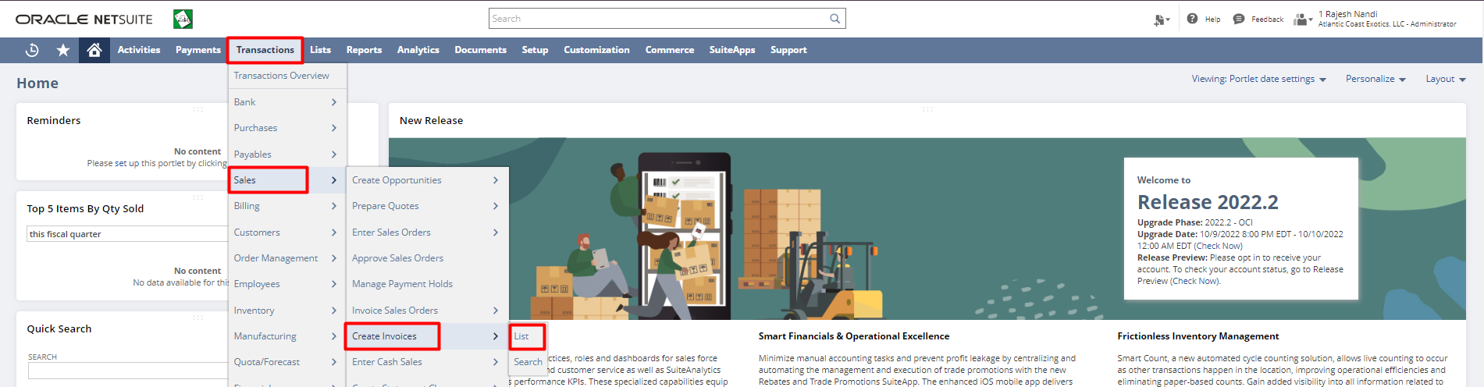
Click “View” on the Invoice for which you want to create a customer payment.

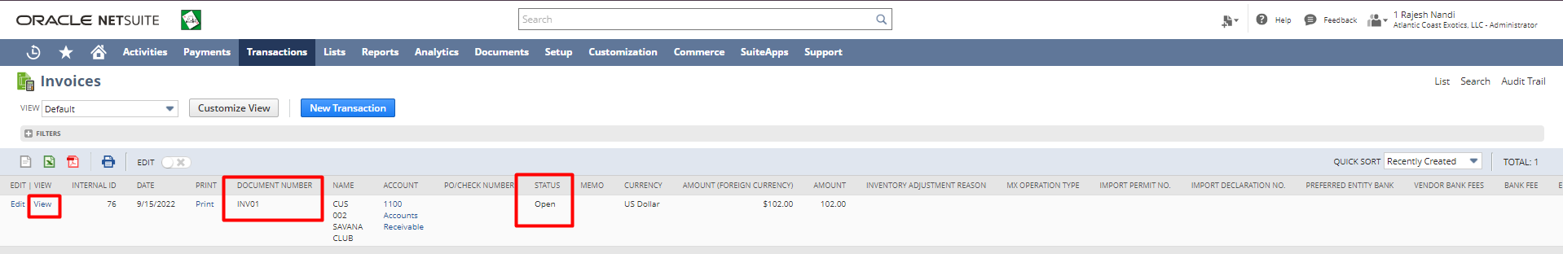

Click on the “Accept Payment” button.
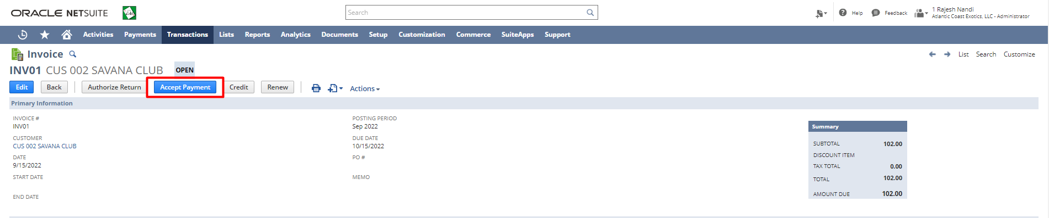
Enter Additional Information in the fields if any. Click on the “Account” radio button. Select the Account for the Payment. Click the “Save” button.

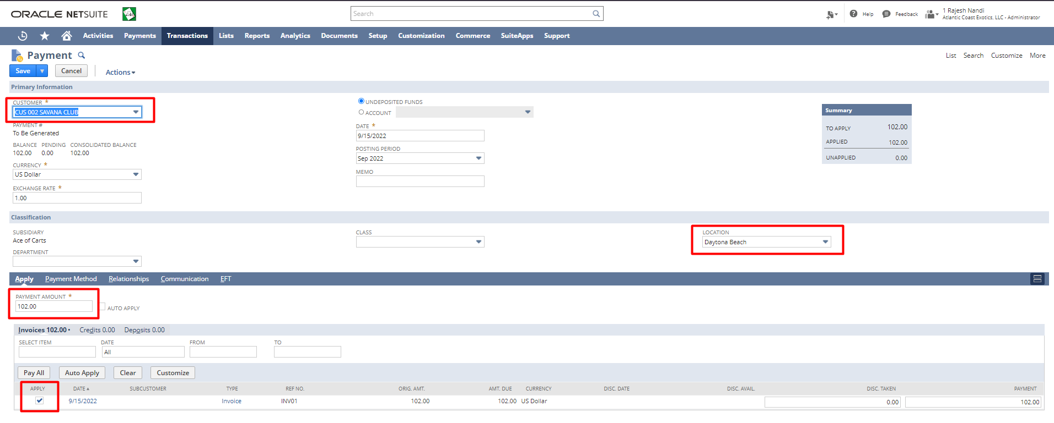
Creating Return Authorization
- Stand Alone
- From Invoice
Stand Alone Return Authorization
1.Login to NetSuite with Administrator Role. Navigate: Transactions -> Customers -> Enter Return Authorizations.
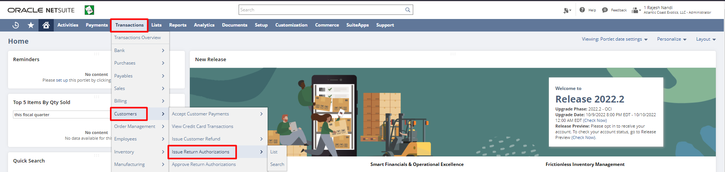
Select Customer and all the required details. Click on the “Save” button.

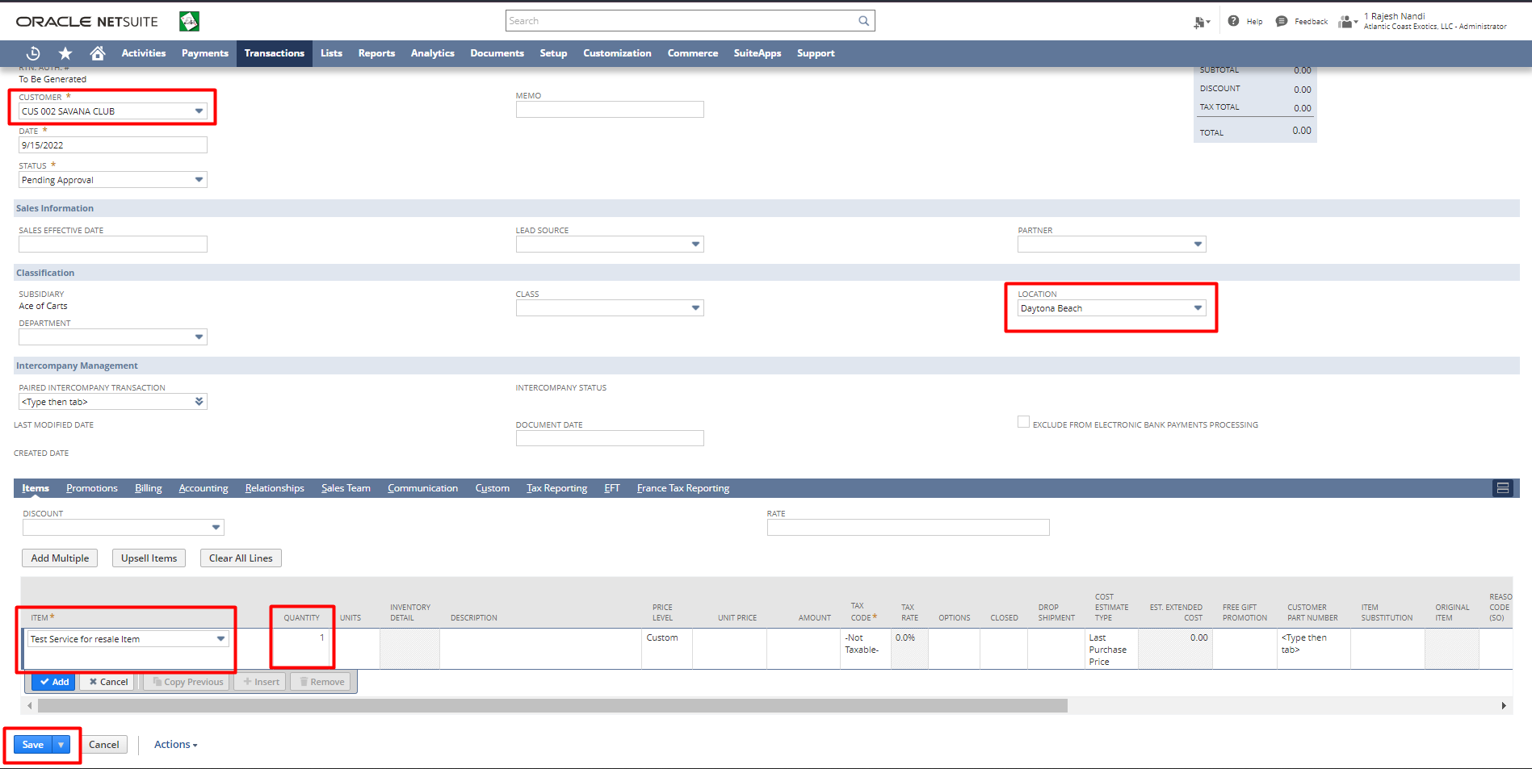
Return Authorization from Invoice
1.Login to NetSuite with Administrator Role. Navigate: Transactions -> Sales-> Create Invoices -> List.

Click the Document Number on the Invoice for which you want to create a return authorization.

Click “Authorize Return”.
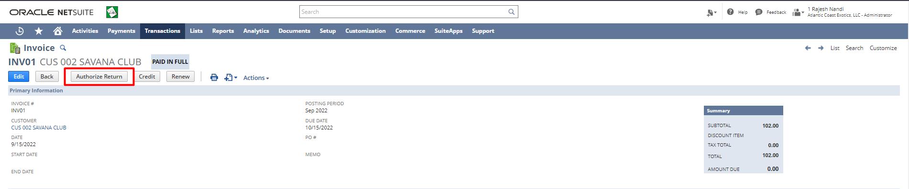
Add additional Information in the fields if any. Click the “Save” button.
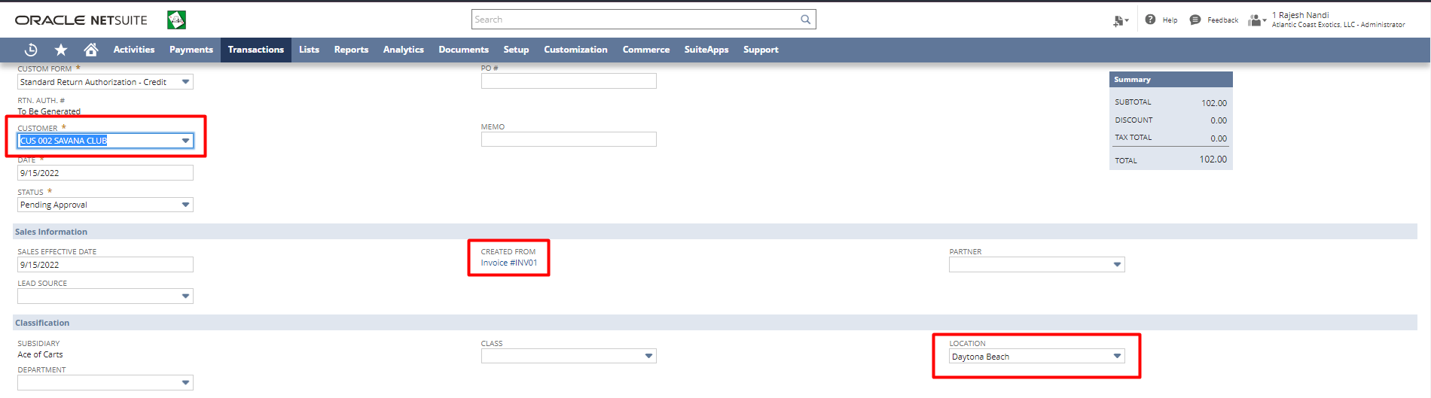
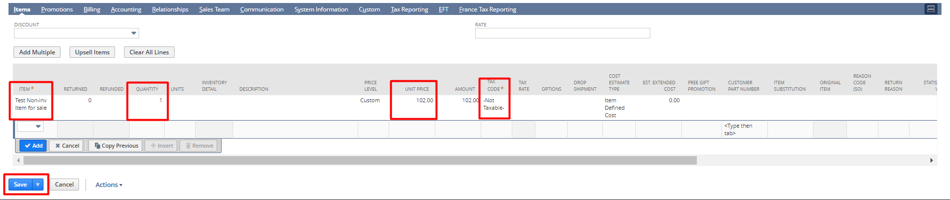

Receiving Return Authorization:
There are two ways to Fulfill Sales Order
- Bulk Receive Returned Orders
- From Return Authorization
Bulk Receiving Returned Orders
Login to NetSuite with Administrator Role. Navigate: Transactions -> Customers -> Receive Returned Order.
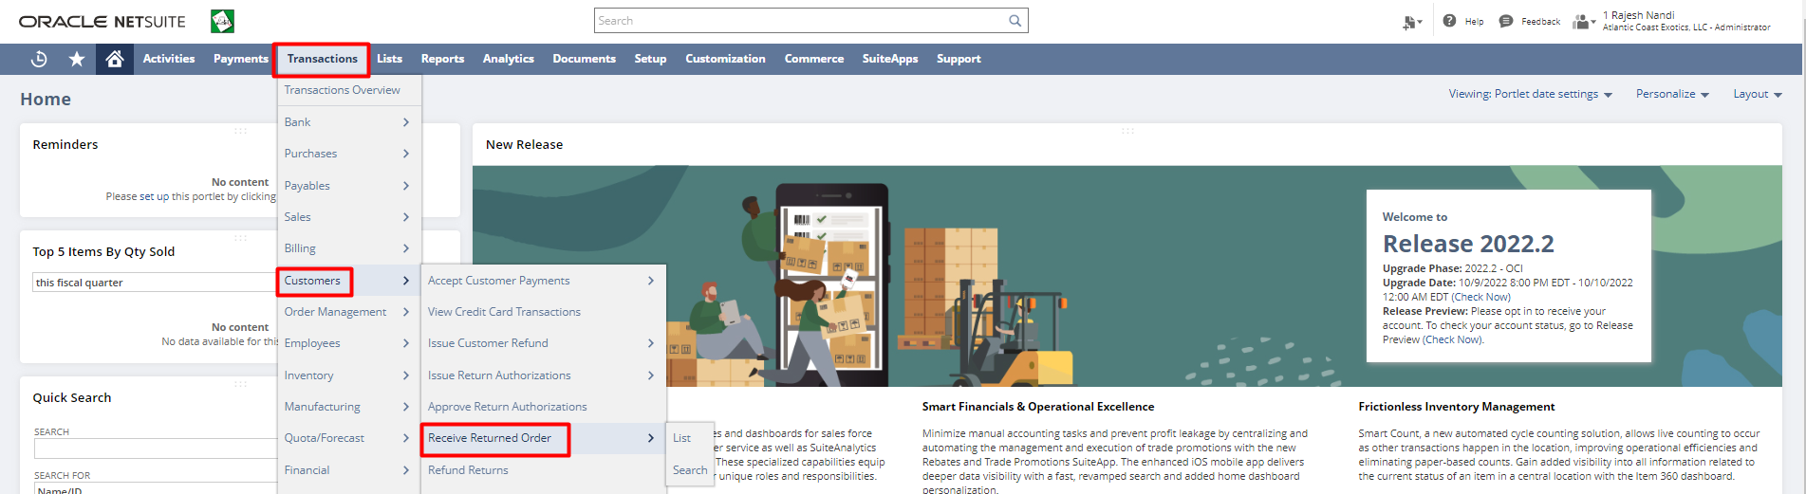
Select all the required details. Click on the “Submit” button.
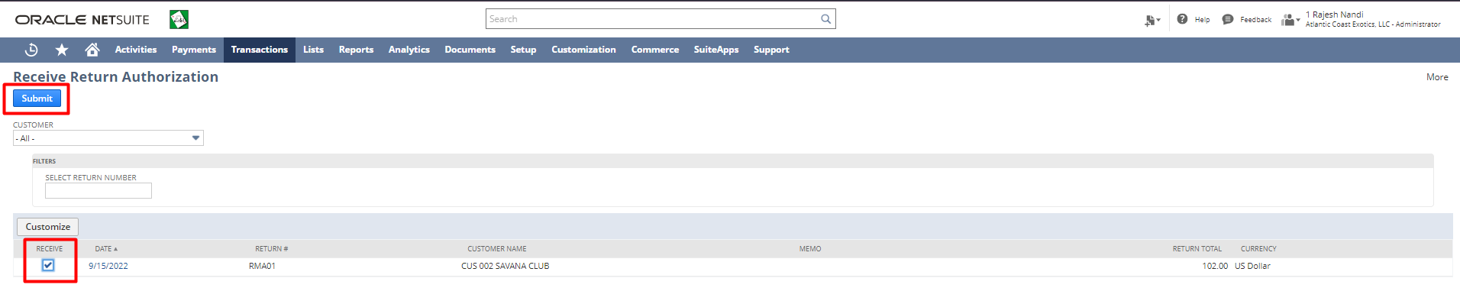
Click the “Save” button.
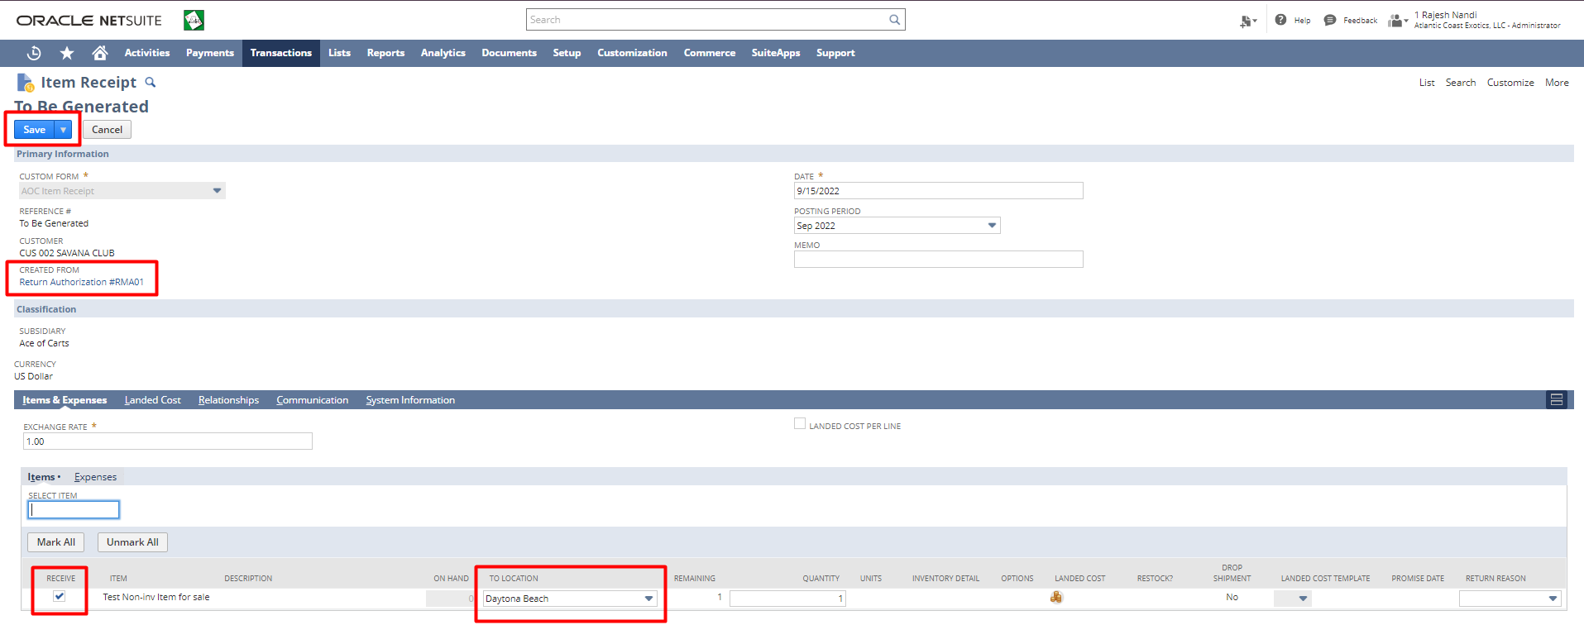
From Return Authorization
Login to NetSuite with Administrator Role. Navigate: Transactions -> Customers -> Issue Return Authorizations -> List.
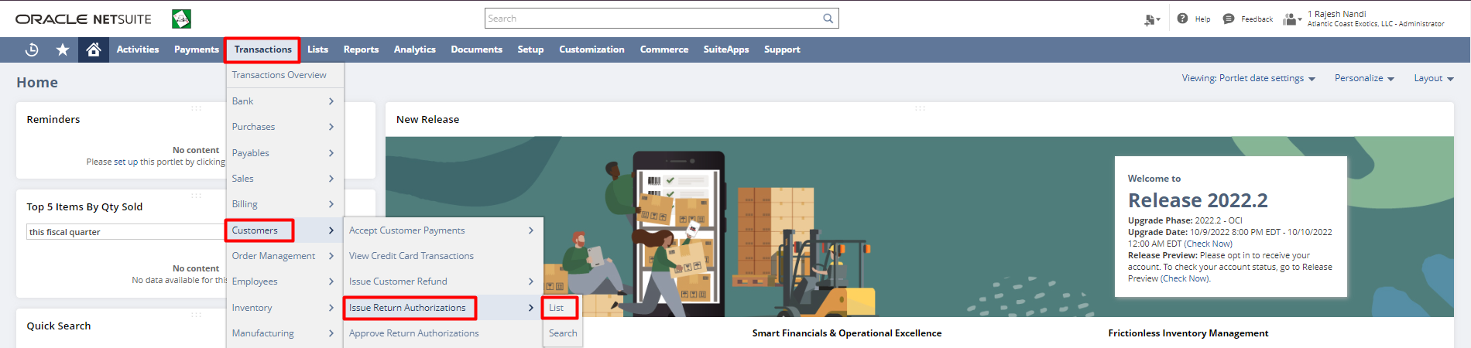
Click “View” on the Return Authorization for which you want to create an Item Receipt.
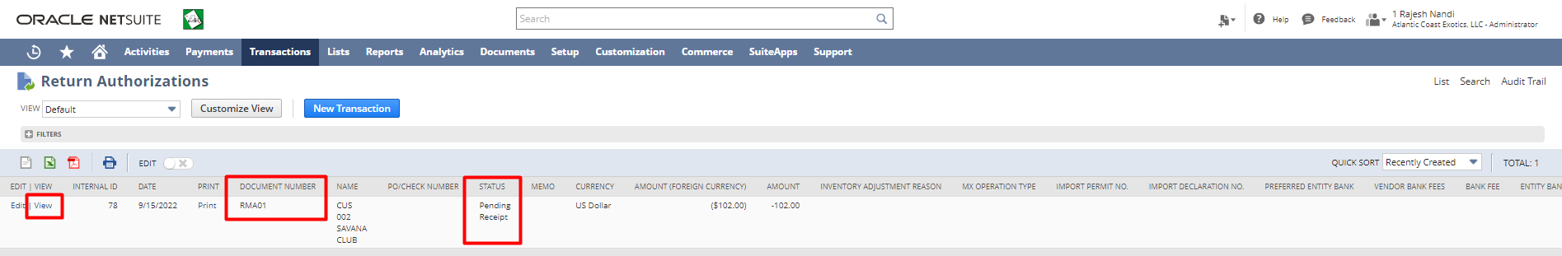
Click “Receive”.
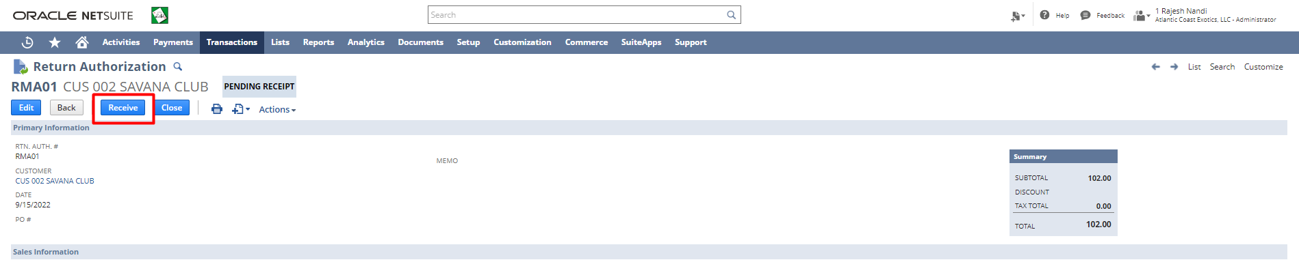
Check the checkbox for the Items you want to receive. Select the Location. Click the “Save” button.
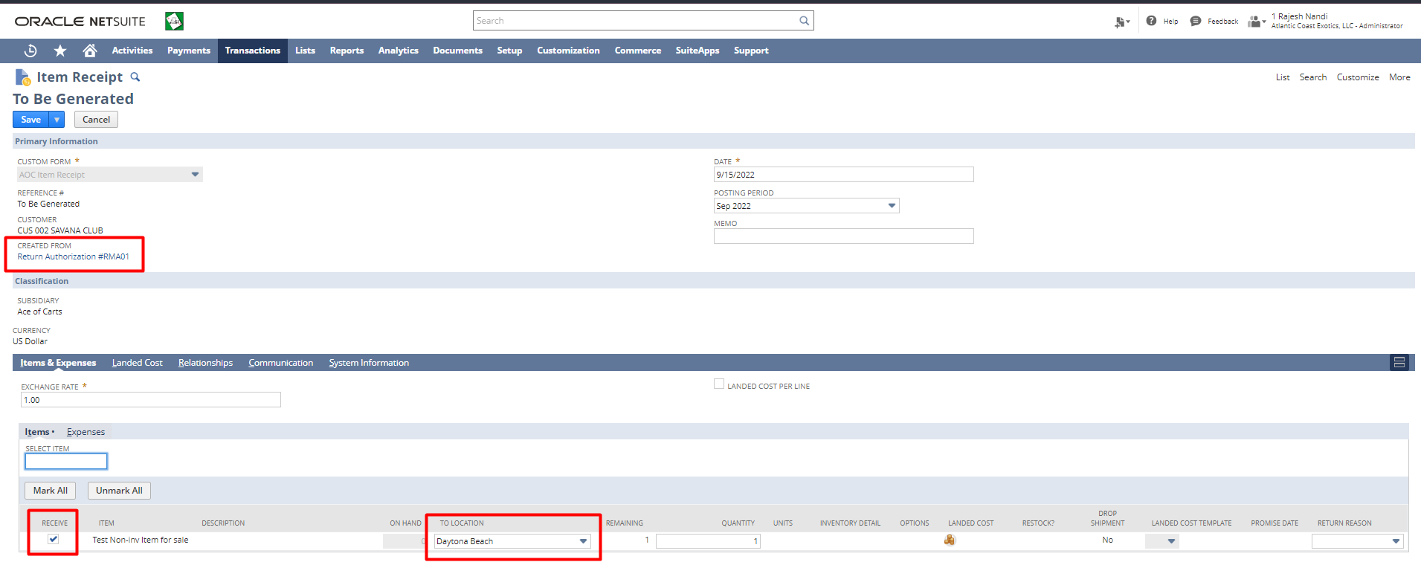
Create Credit Memo for Return Authorization:
Login to NetSuite with Administrator Role. Navigate: Transactions -> Customers -> Issue Return Authorizations -> List. 
Click “View” on the Return Authorization for which you want to create a refund.
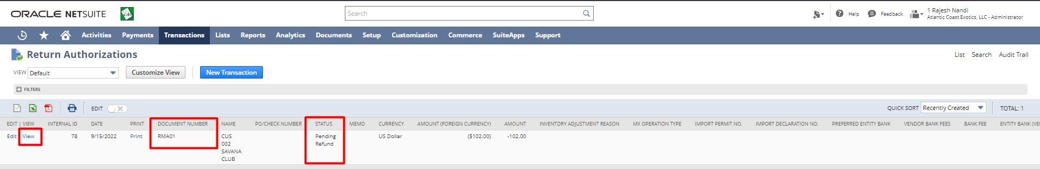
Click “Refund”.
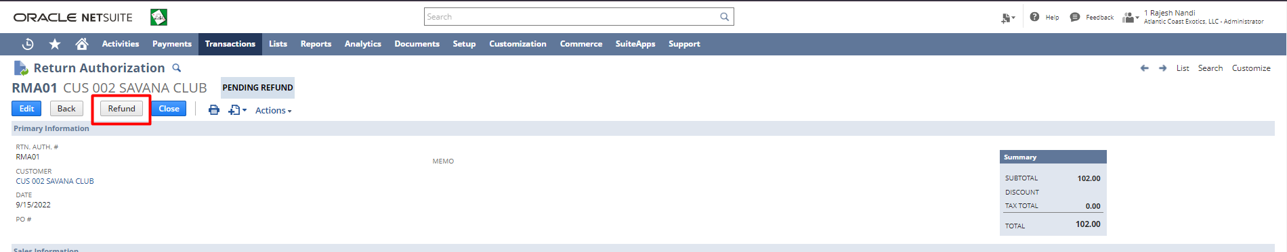
Enter Additional Information if any. Click the “Save” button.
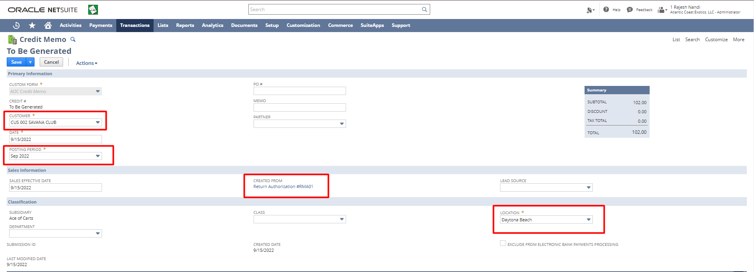
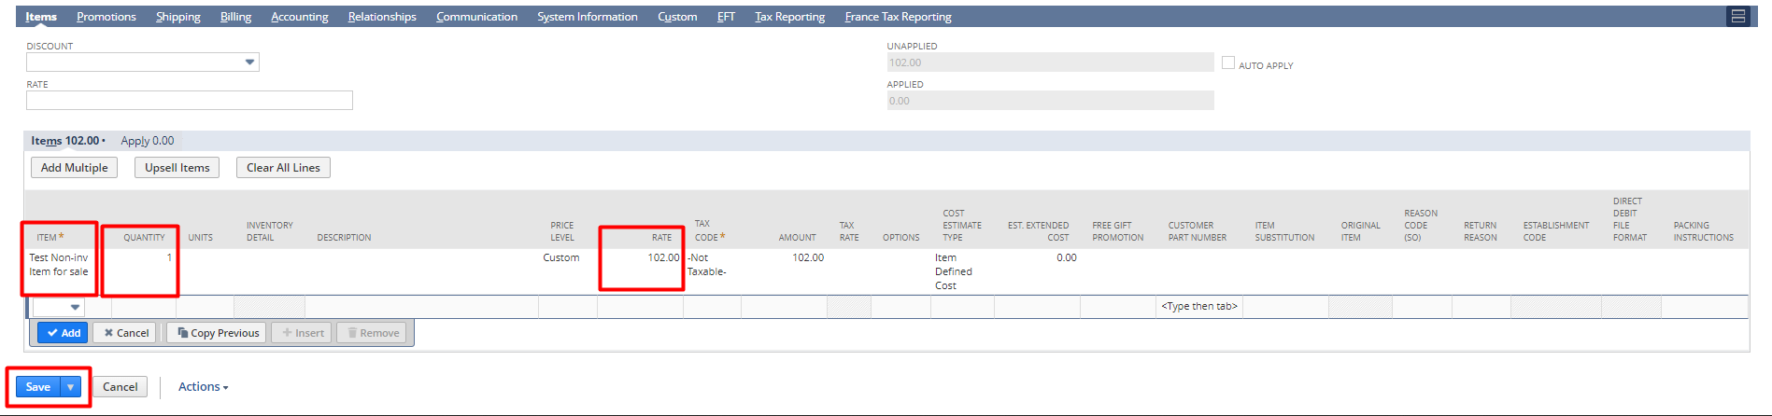

Disclaimer: Upon signing off on the process flow document, you are confirming that the process has been set up per the SOW within NetSuite per your business's needs. Any additional changes or modifications requested outside the initial scope of work could result in a change request at an additional fee.
*** PLEASE ensure that you have logged into NetSuite and tested the process prior to signing off on the setup. Paapri requires sign-off on this document prior to moving forward with any additional design meetings.

